**AUTOMATE APPLICATIONS USING ANSIBLE**



**Team Name:** Cloud Storms

**Team Number:** 26

**Team Members:**

Prasad Reddy

Naga Balaji Reddy

Sunil

Rama Reddy

**SCOPE:**

Ansible is a popular automation tool that allows you to automate IT tasks such as configuration management, application deployment, and infrastructure management. Its scope is vast, and it can be used to automate a wide range of applications and systems.

Some of the popular use cases for Ansible automation include:

**Configuration management:** Ansible can be used to automate the configuration of servers, networking devices, and other IT resources. This includes tasks such as setting up users and permissions, installing software and packages, and configuring services.

**Application deployment:** Ansible can automate the deployment of applications and their dependencies, including web servers, databases, and load balancers. This can be particularly useful in environments where frequent updates and deployments are required.

**Infrastructure management:** Ansible can automate the provisioning of infrastructure resources such as virtual machines, containers, and cloud instances. This includes tasks such as creating and configuring network interfaces, storage volumes, and security groups.

**Security automation:** Ansible can be used to automate security-related tasks such as vulnerability scanning, patch management, and compliance auditing.

Overall, Ansible's flexibility and wide range of capabilities make it a valuable tool for automating various IT tasks and applications.

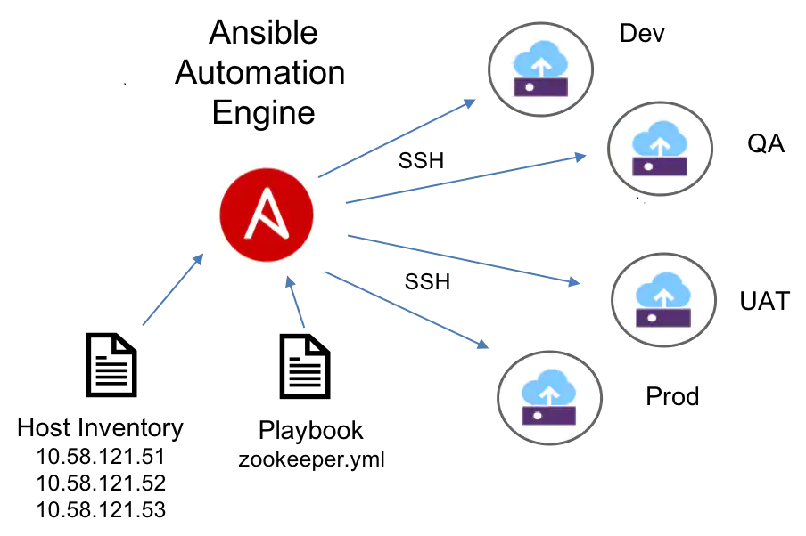

**PURPOSE:**

The purpose of automating applications using Ansible is to simplify and streamline IT operations. By automating routine tasks, such as software installation, configuration management, and infrastructure provisioning, Ansible can save time and reduce the risk of errors that can occur with manual processes.

Some of the key benefits of automating applications with Ansible include

**Improved efficiency:** Ansible enables you to automate repetitive tasks, freeing up time for IT teams to focus on more strategic work.

**Consistency:** Automation with Ansible ensures that IT operations are standardized and consistent, reducing the risk of errors and security vulnerabilities.

**Speed:** Ansible can execute tasks much faster than manual processes, reducing the time it takes to deploy applications and infrastructure.

**Scalability:** Ansible is highly scalable and can automate tasks across large numbers of servers and devices.

**Collaboration:** Ansible provides a platform for collaboration between IT teams, allowing for the sharing of playbooks and roles that can be used across the organization.

Overall, the purpose of automating applications with Ansible is to improve efficiency, consistency, speed, and scalability, while reducing the risk of errors and increasing collaboration between IT teams.

**TOOLS & TECHNOLOGIES USED:**

**Ansible:**

* Ansible is an open-source automation tool.
* It uses YAML-based playbooks to define desired system state.
* Ansible is agentless, lightweight, and easy to set up.

**Git & Git-Hub:**

* Git is a distributed version control system.
* It allows developers to track changes to their code over time.
* Git enables collaboration among developers by allowing them to work on the same codebase simultaneously.

**AWS:**

* AWS (Amazon Web Services) is a cloud computing platform that provides a wide range of services and solutions for businesses and individuals.
* It offers on-demand computing resources, such as virtual machines, storage, and databases, that can be accessed over the internet.

**Slack:**

* Slack is a messaging platform that can be used to notify team members about the status of the deployment process.
* Ansible can be configured to send notifications to Slack channels when certain tasks are completed or when there are errors in the deployment process.

**JIRA:**

* JIRA is a project management tool that can be used to track issues and bugs during the deployment process.
* Ansible can be integrated with JIRA to create tickets automatically when there are errors in the deployment process.

**PROOF OF CONCEPT:**

**Login To aws.amazon.com with your credentials And navigate to console home**

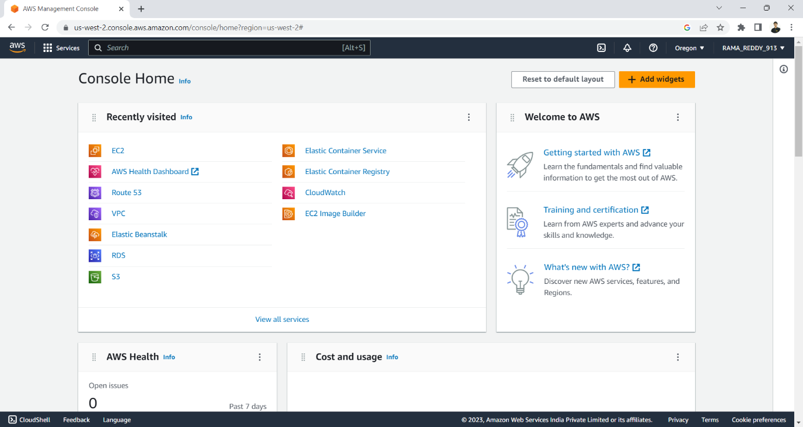**Click on Ec2 then you will be navigated to EC2 Dashboard**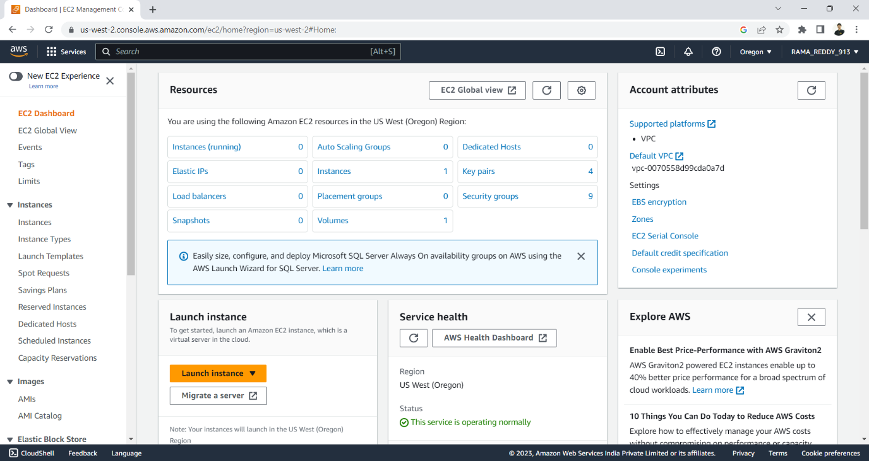

**Click On Instances and Launch 3 instances at a time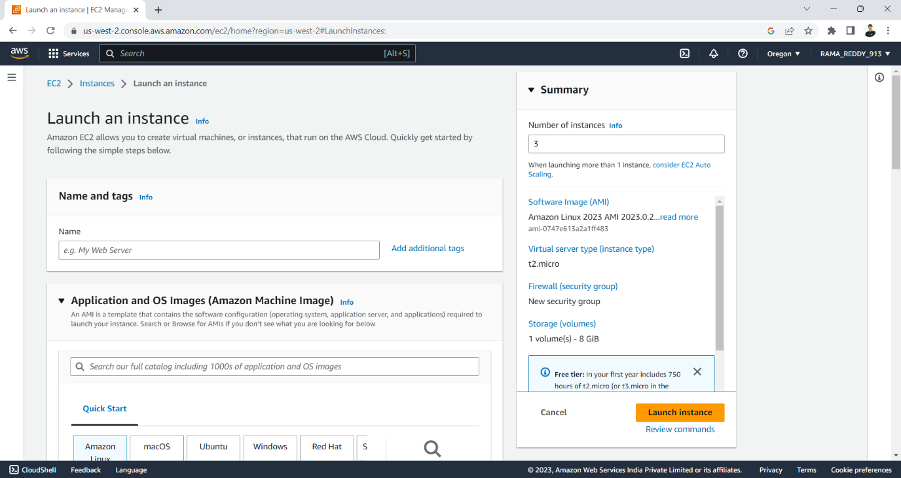Select the AMI (Amazon Machine Image) in our case select Amazon Linux2 And select the Architecture of the operating System.**

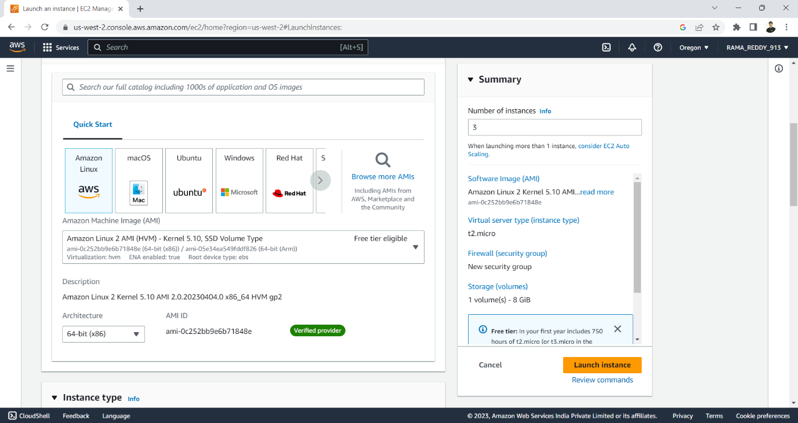

**create a keypair, keypair allows you to connect to your instance .**

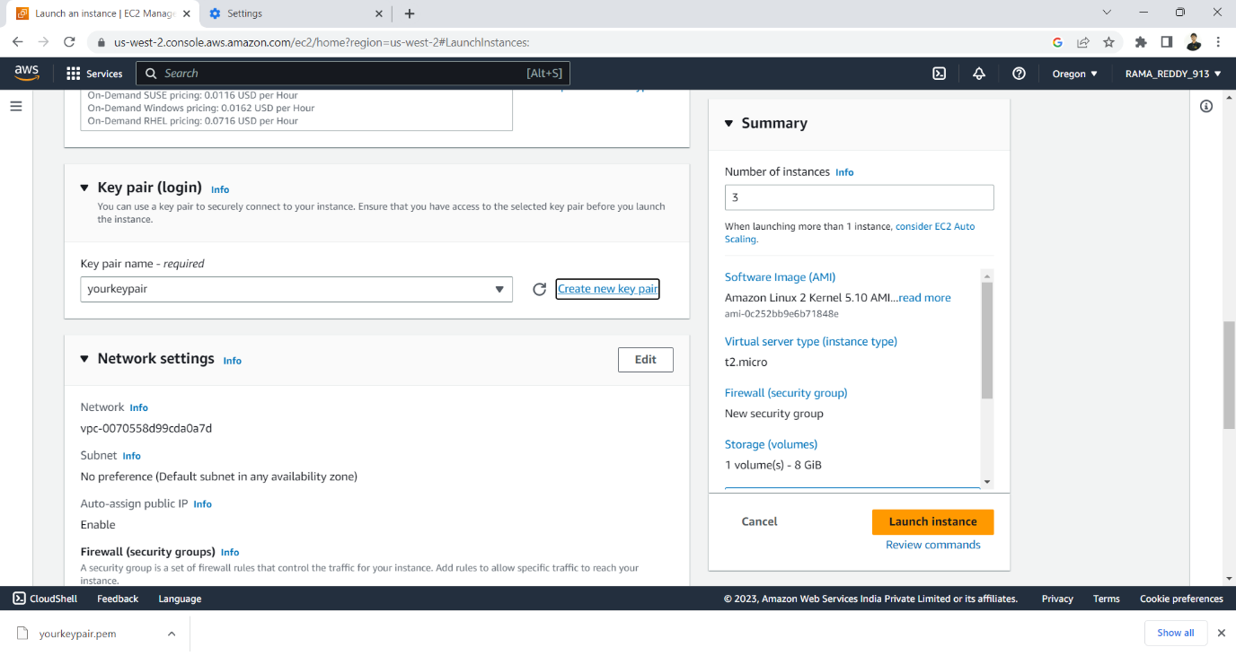

**Selete your keypair and VPC, subnet and enable auto assigne public Ip**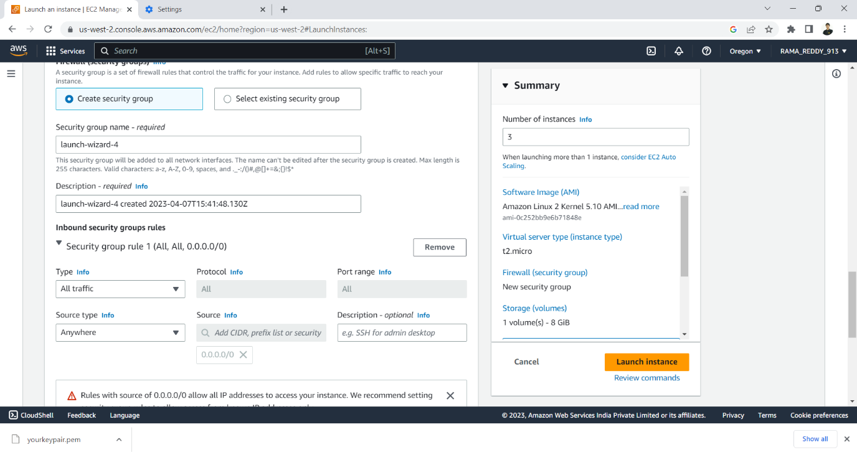

**Click on create security group and select inbound security group rules. In our case select ALL Traffic, finally click on launch instance.**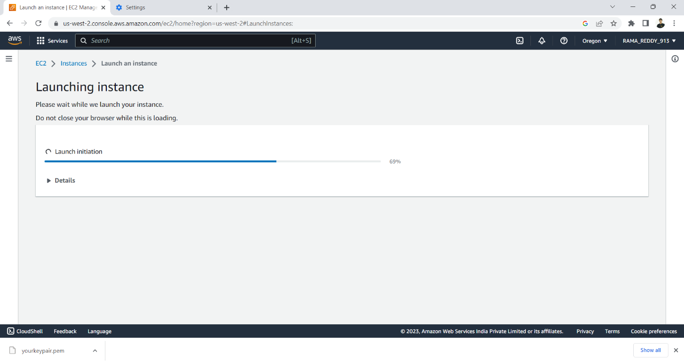

**Instance launched. Rename as Master ,Node1,Node2.**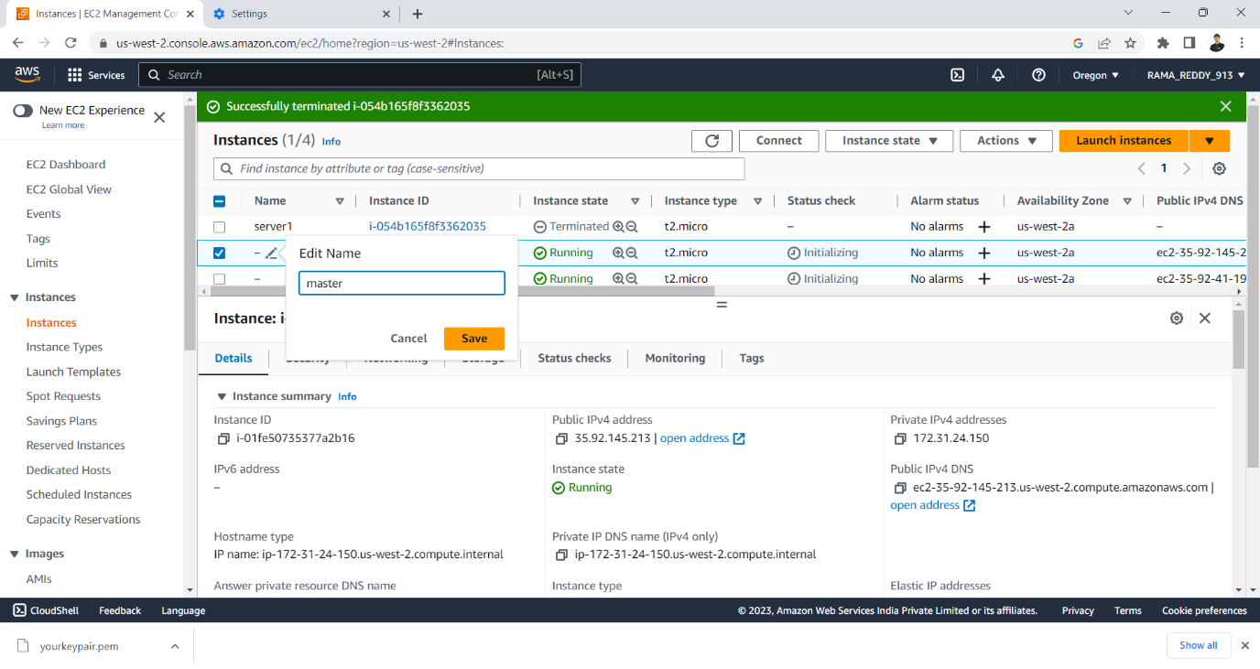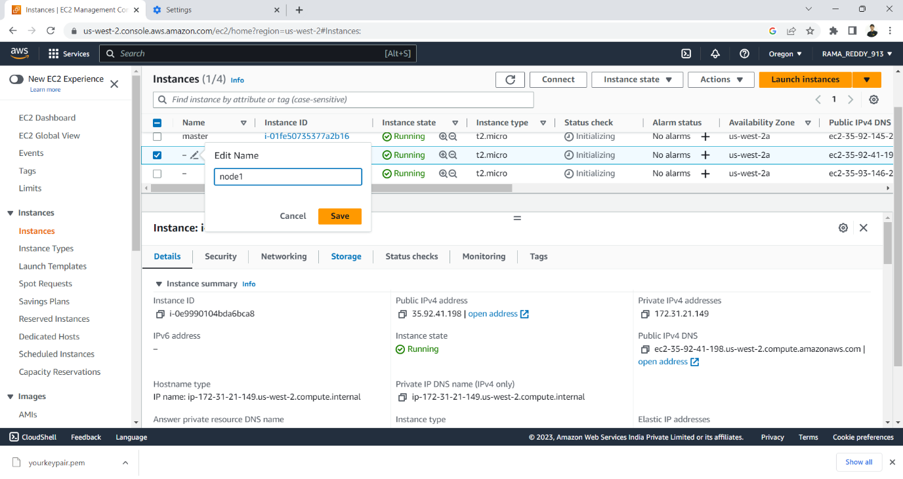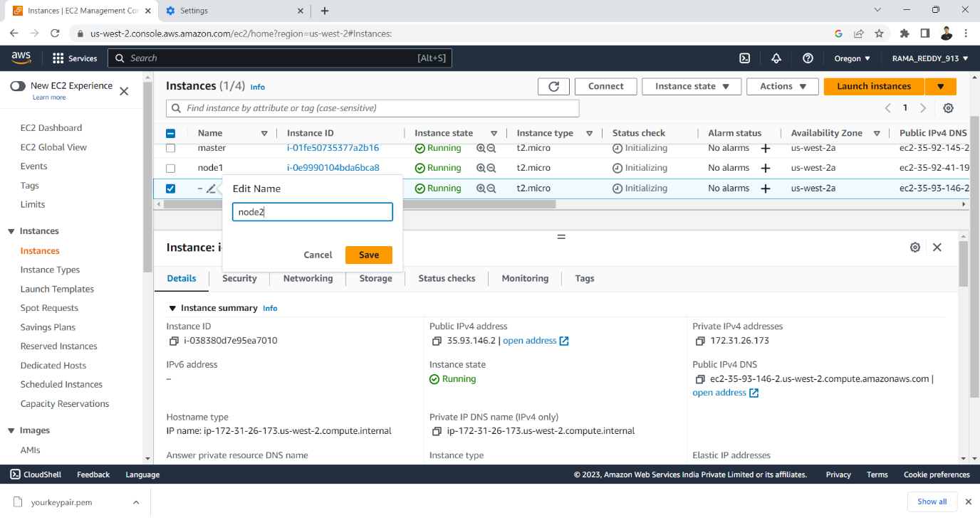

**Connect to master instance and execute the following commands**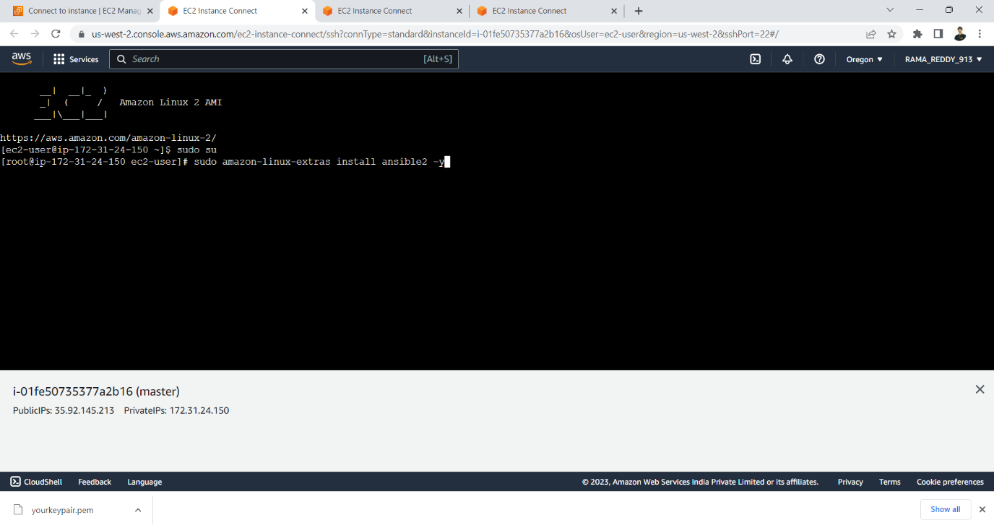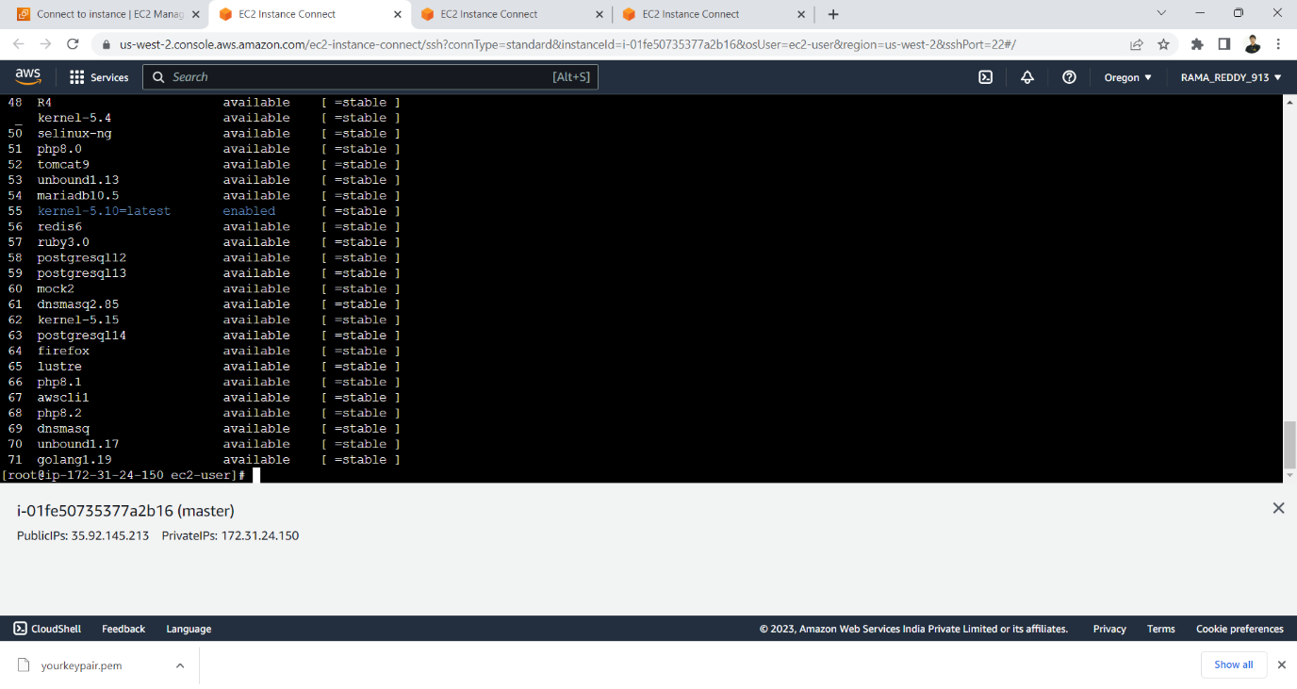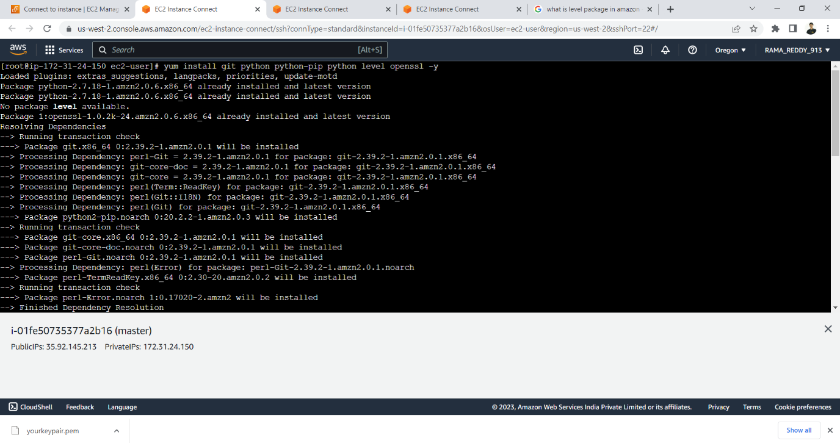

**create a group and enter the public Ip of the nodes**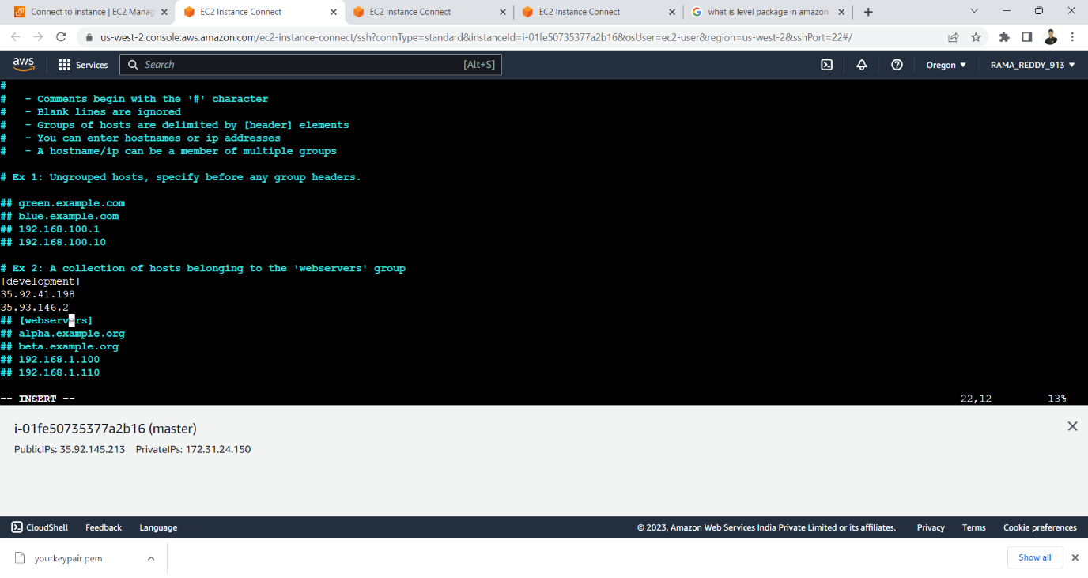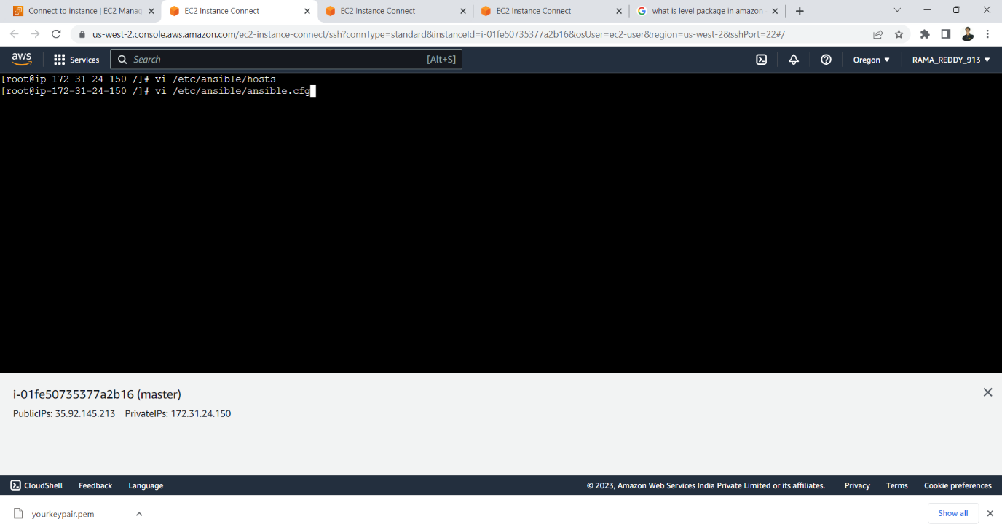

**Uncomment inventory and sudo user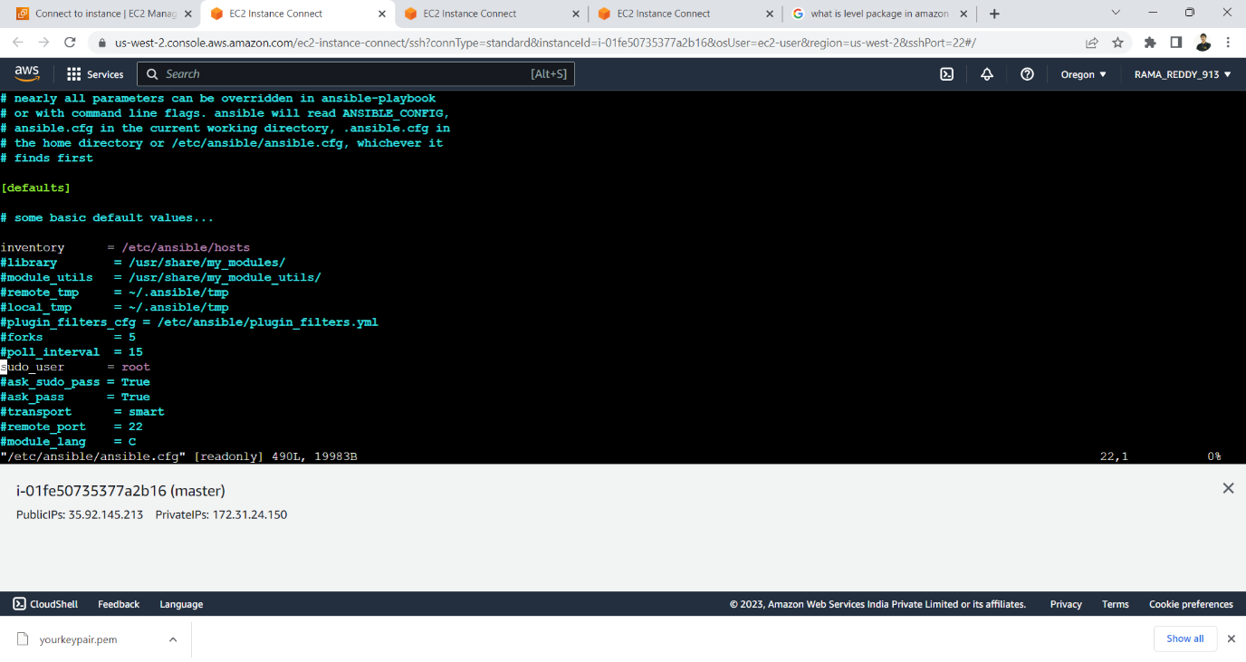create a user named ansible to ensure user is created open /etc/passwd file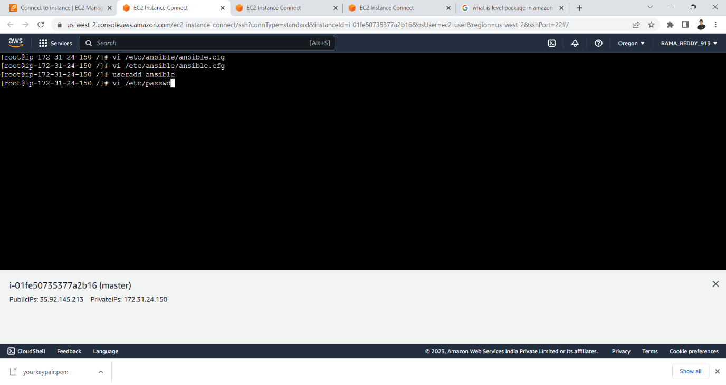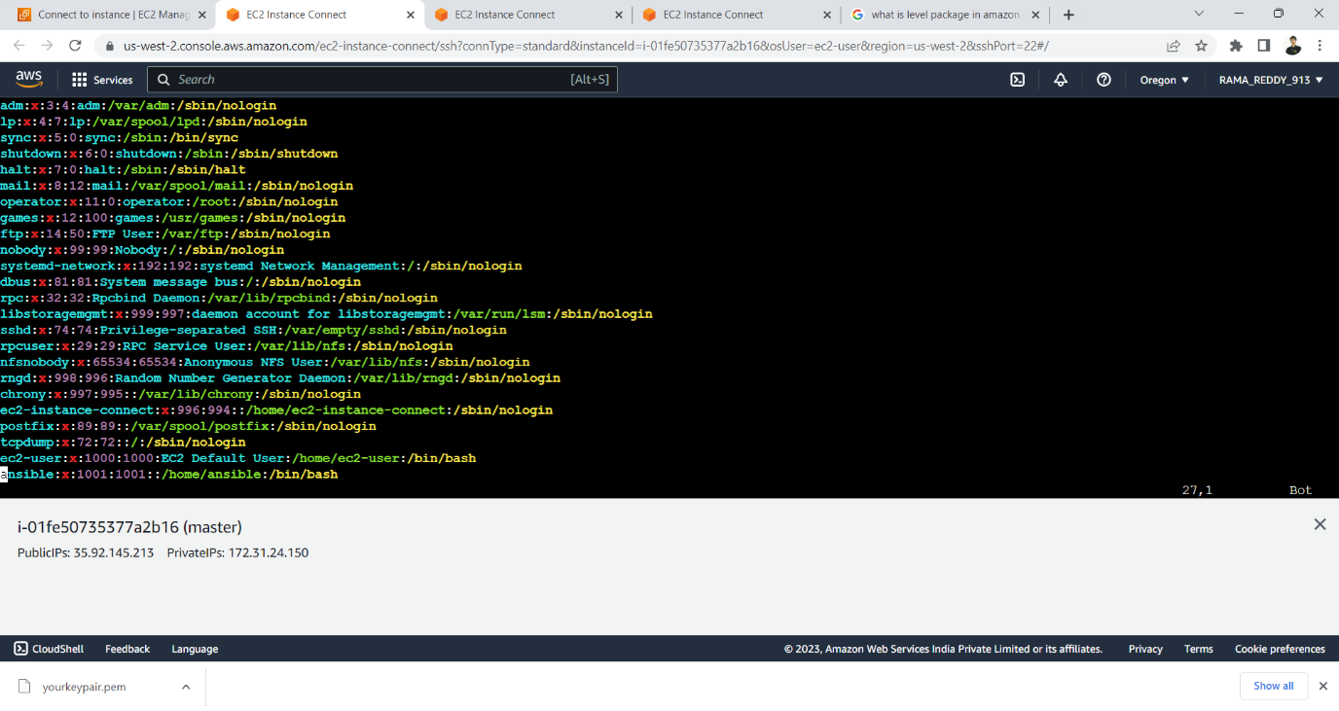give root user prevalags to the user created 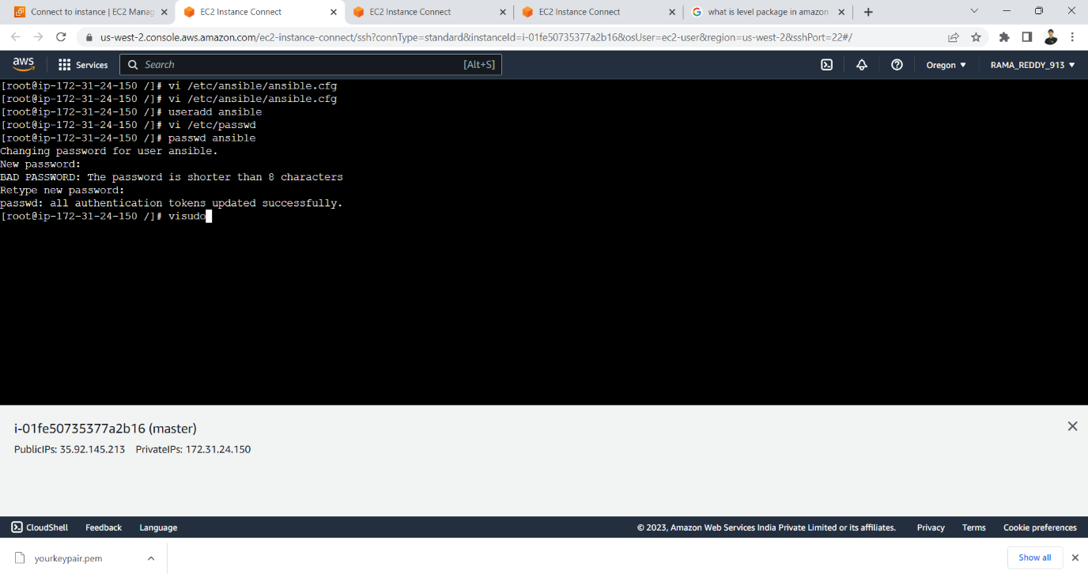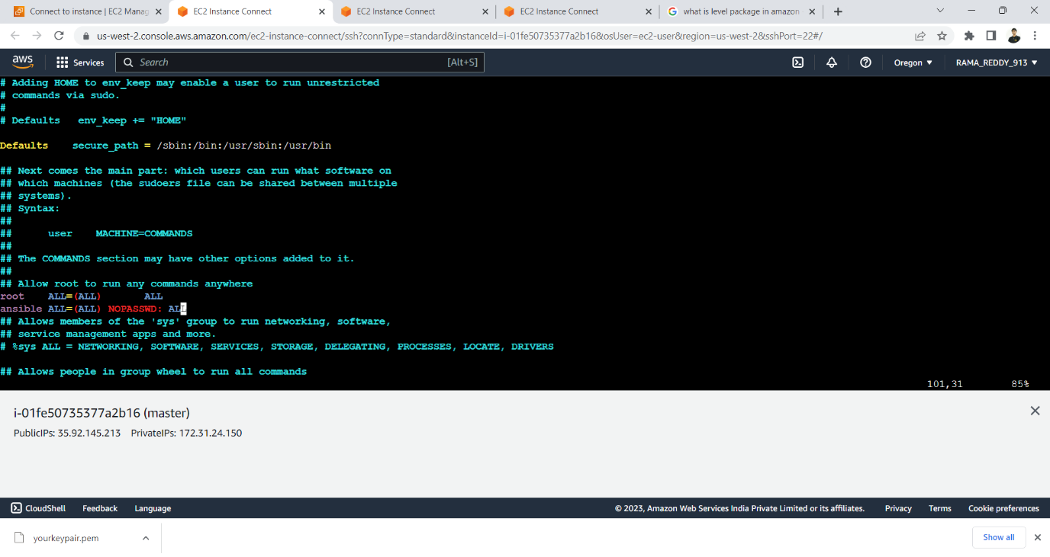open /etc/ssh/sshd_config and change password authentication from no to yes and perform the same process for all the nodes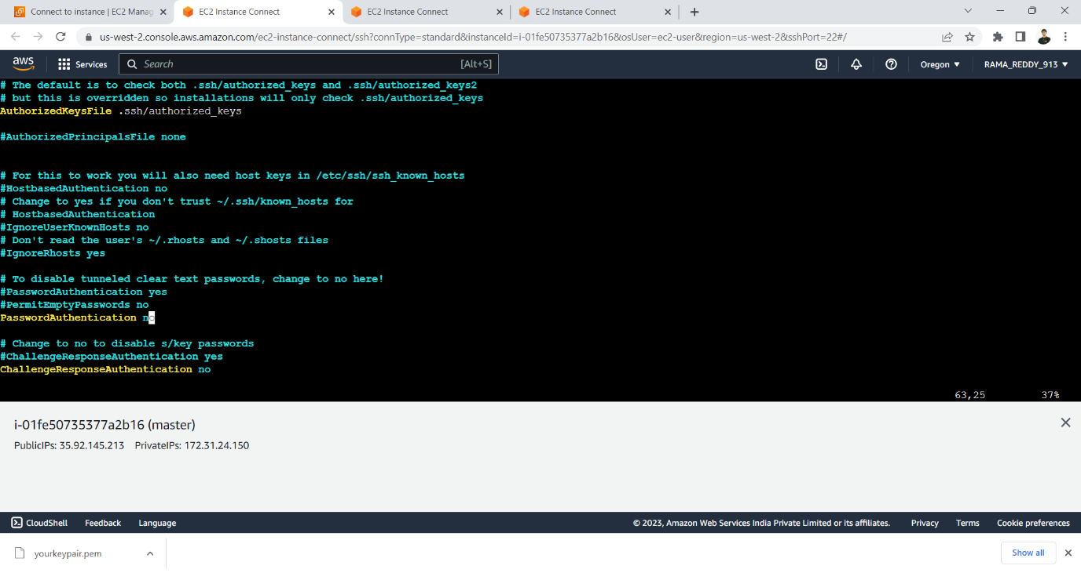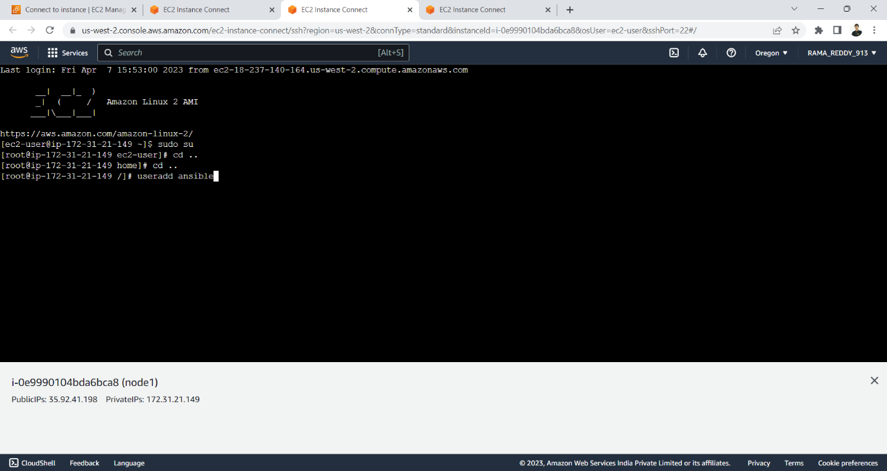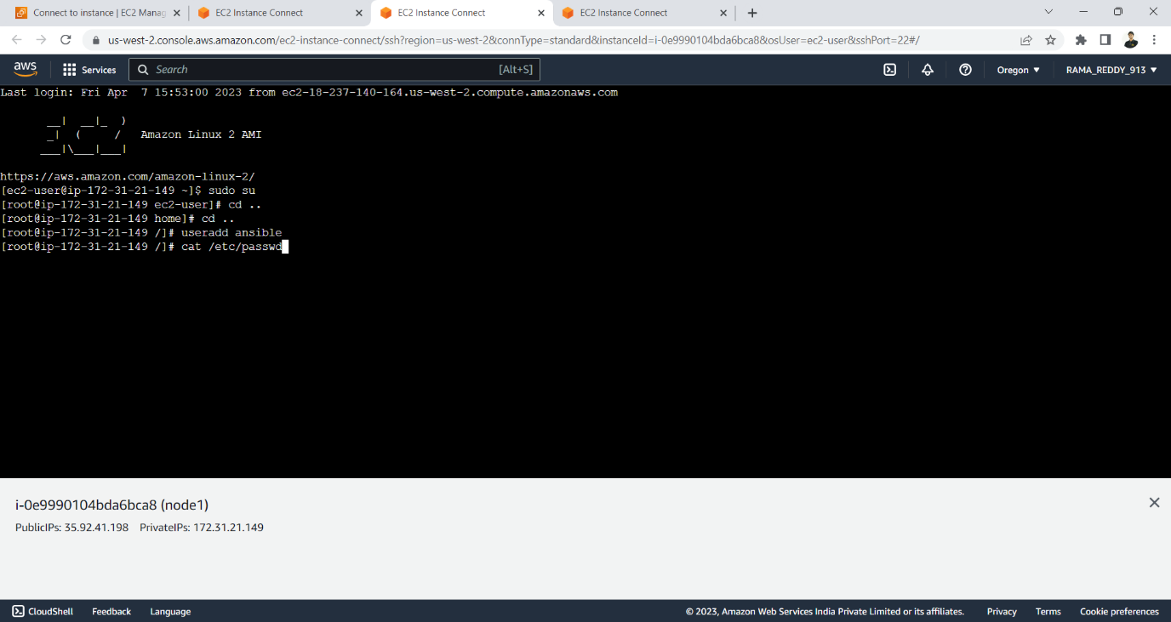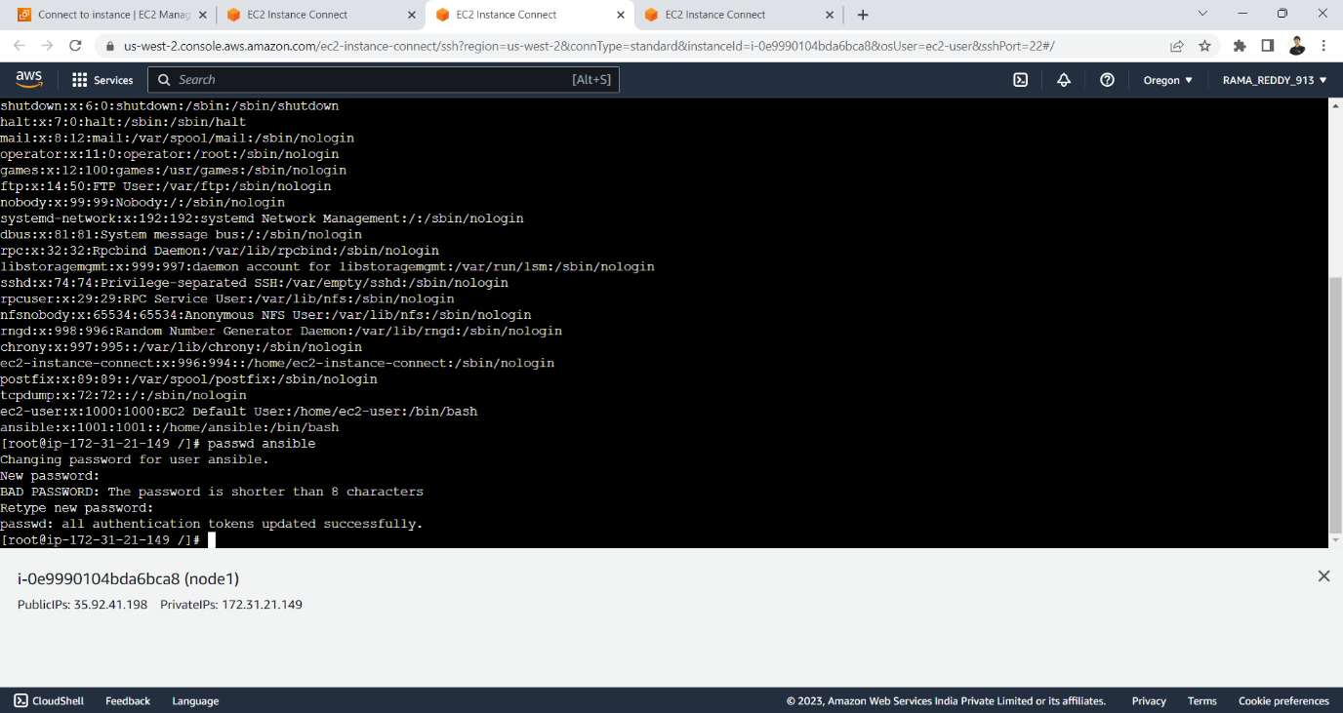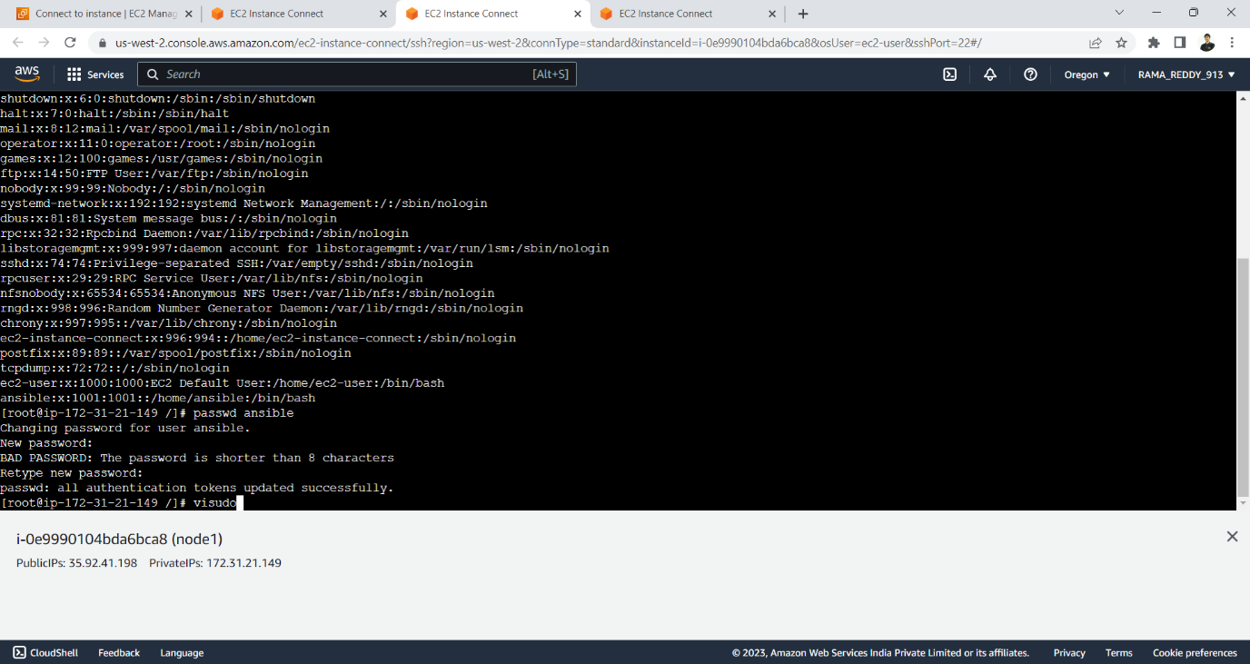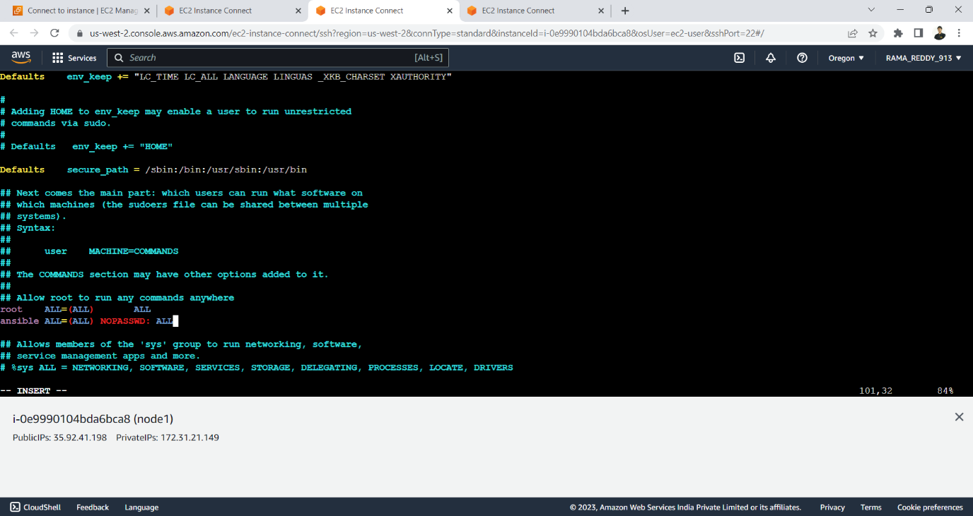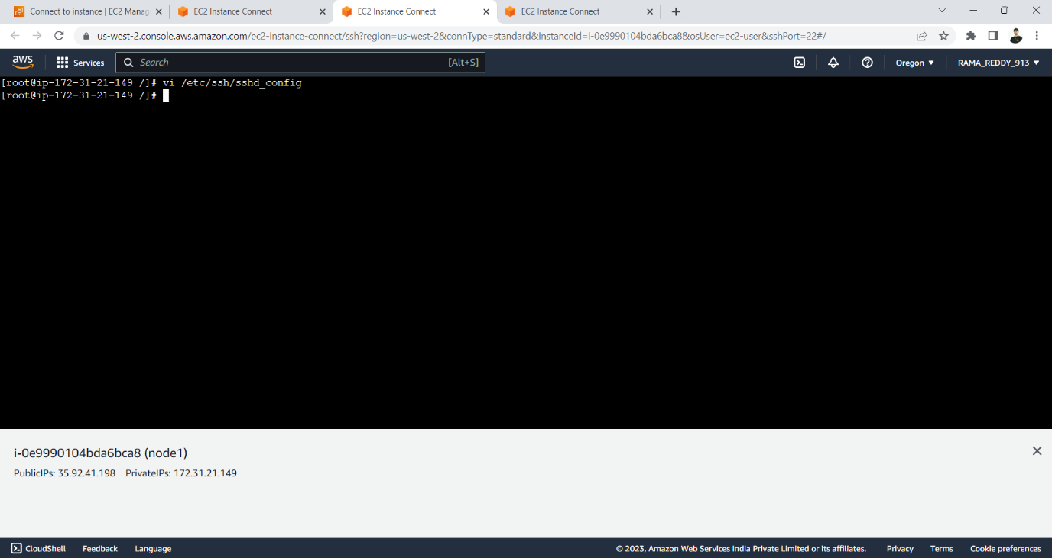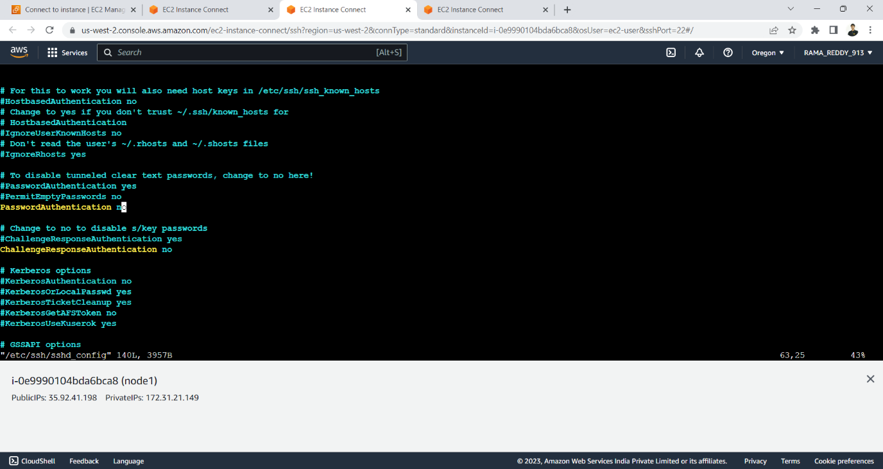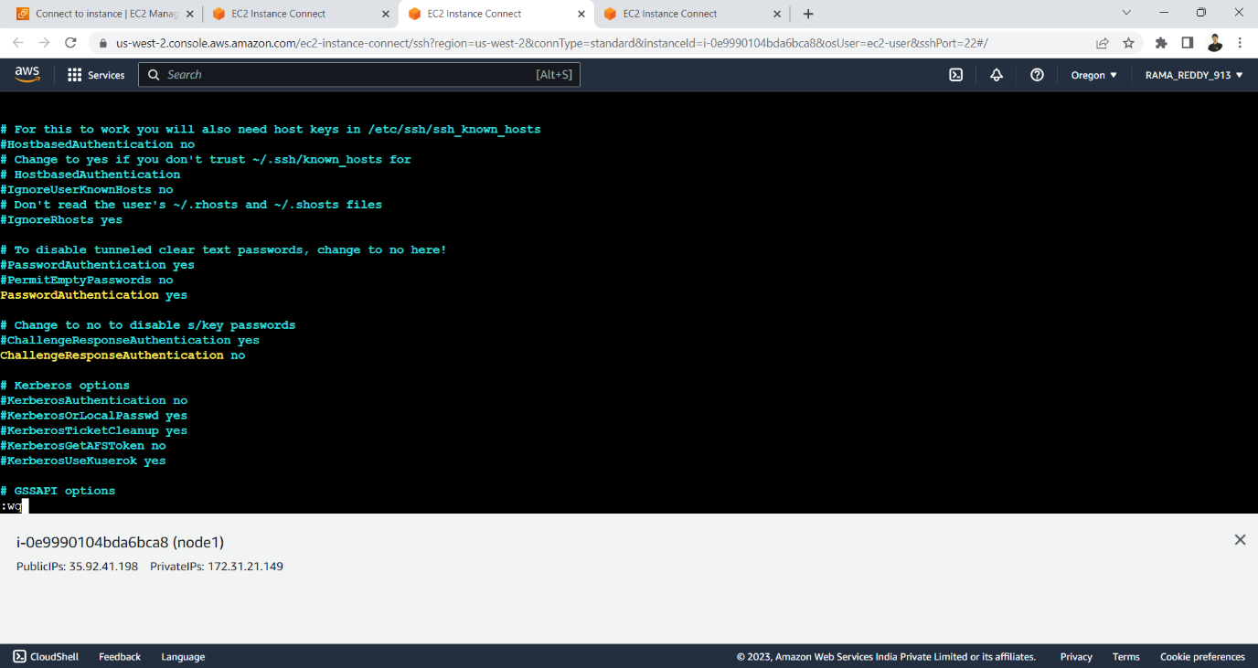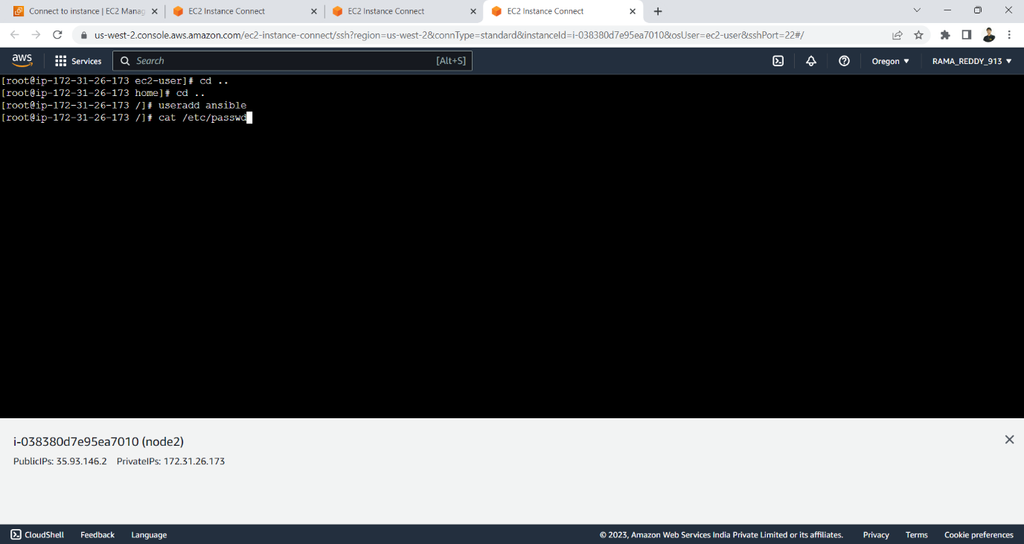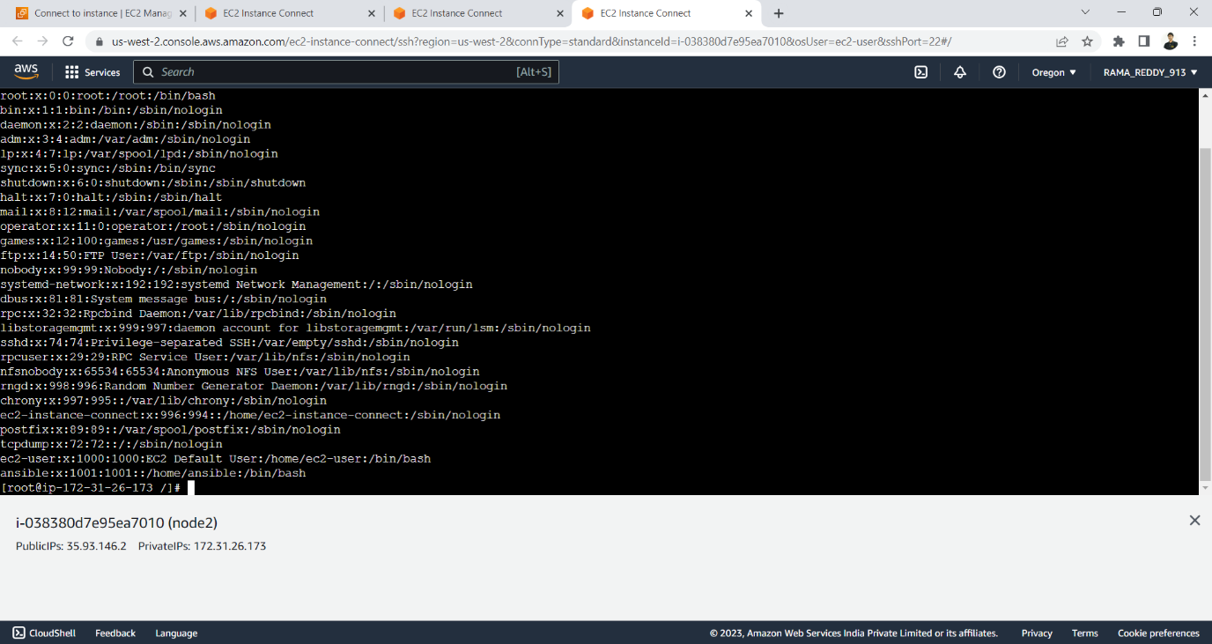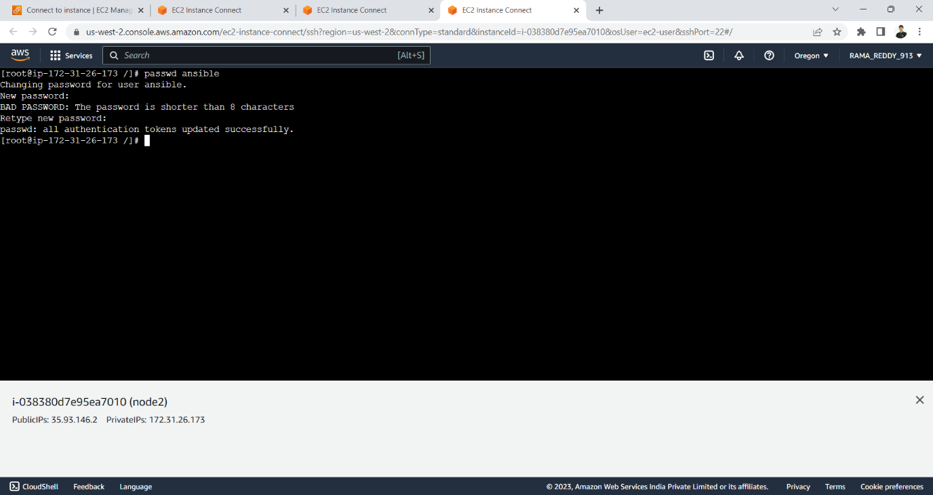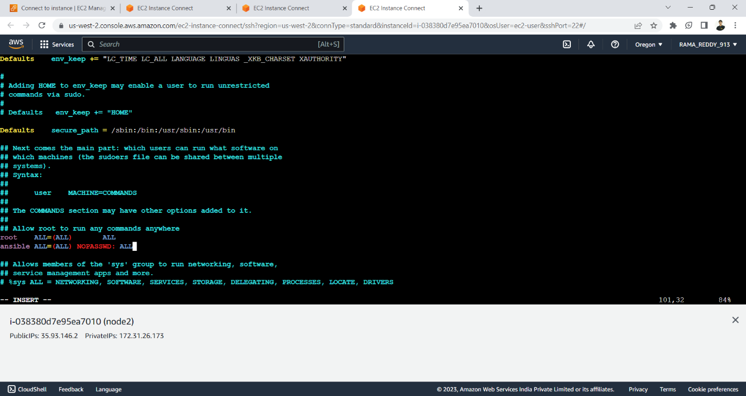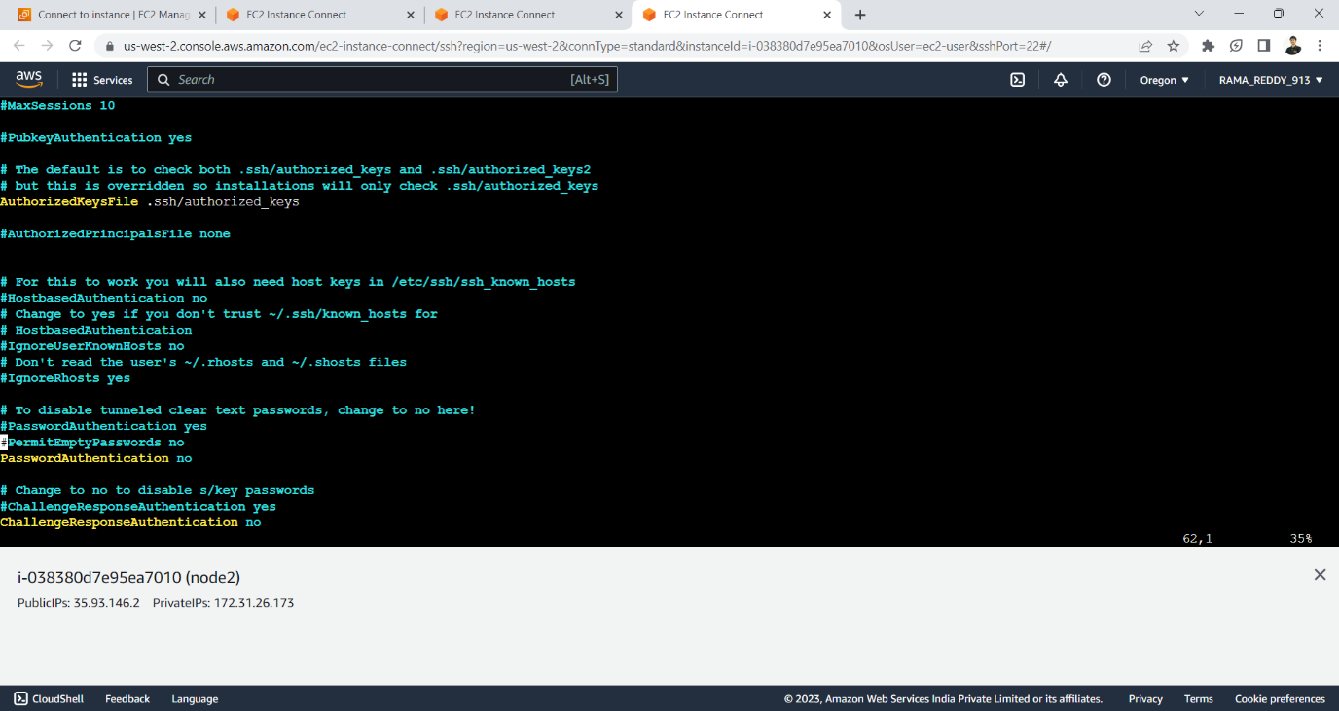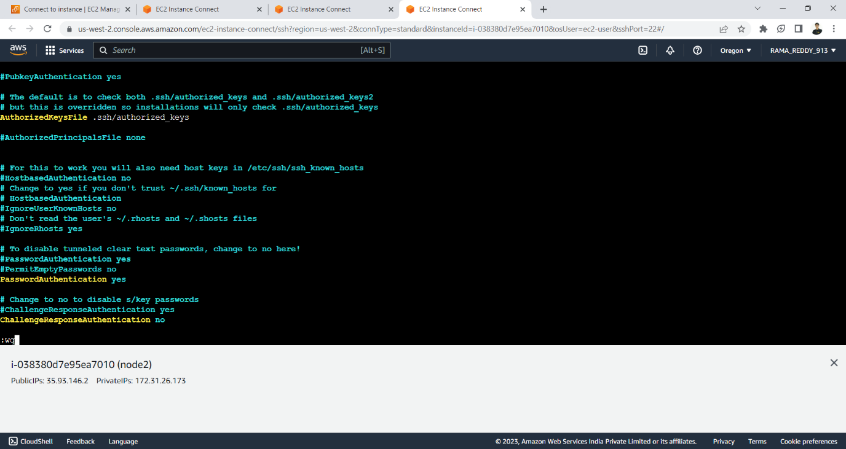 switch to ansible and check the hosts by executing the following commands** 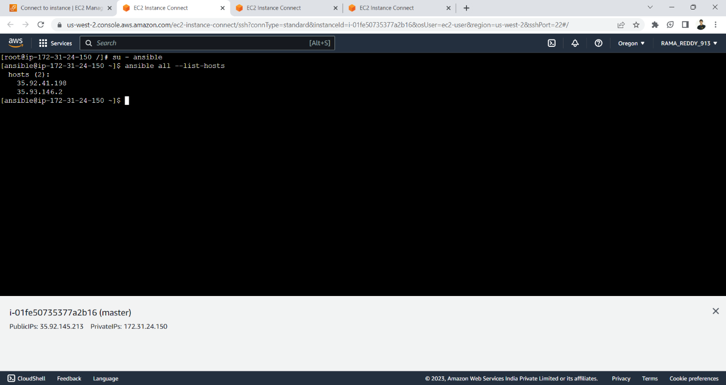

**create a public key by using ssh-keygen command** 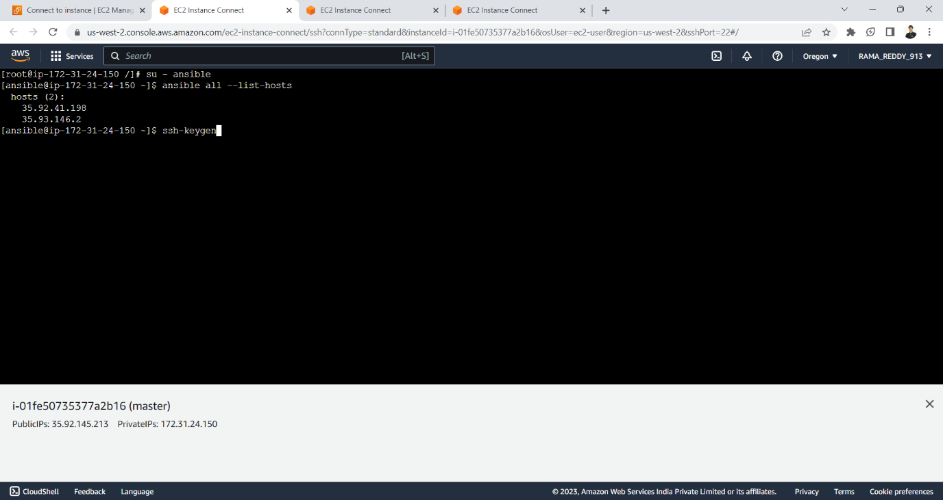 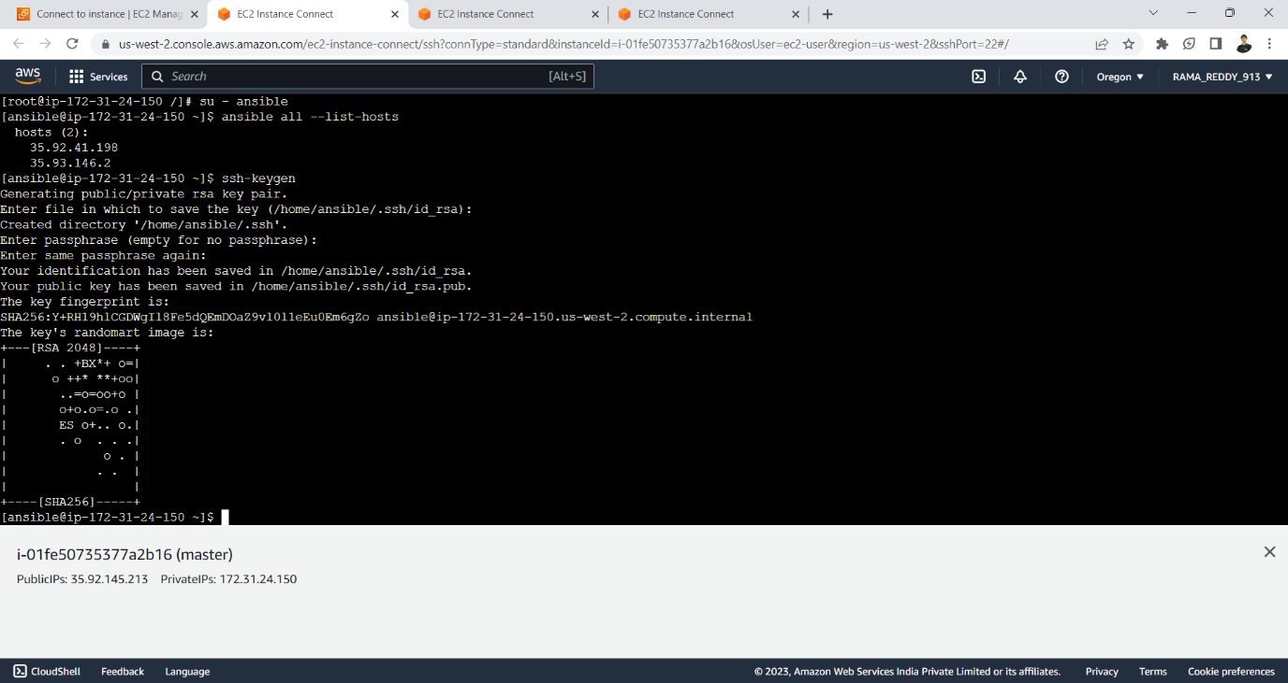

**connect to the node by using ssh command here we have got an error as pemission denied because the public key is not available in the nodes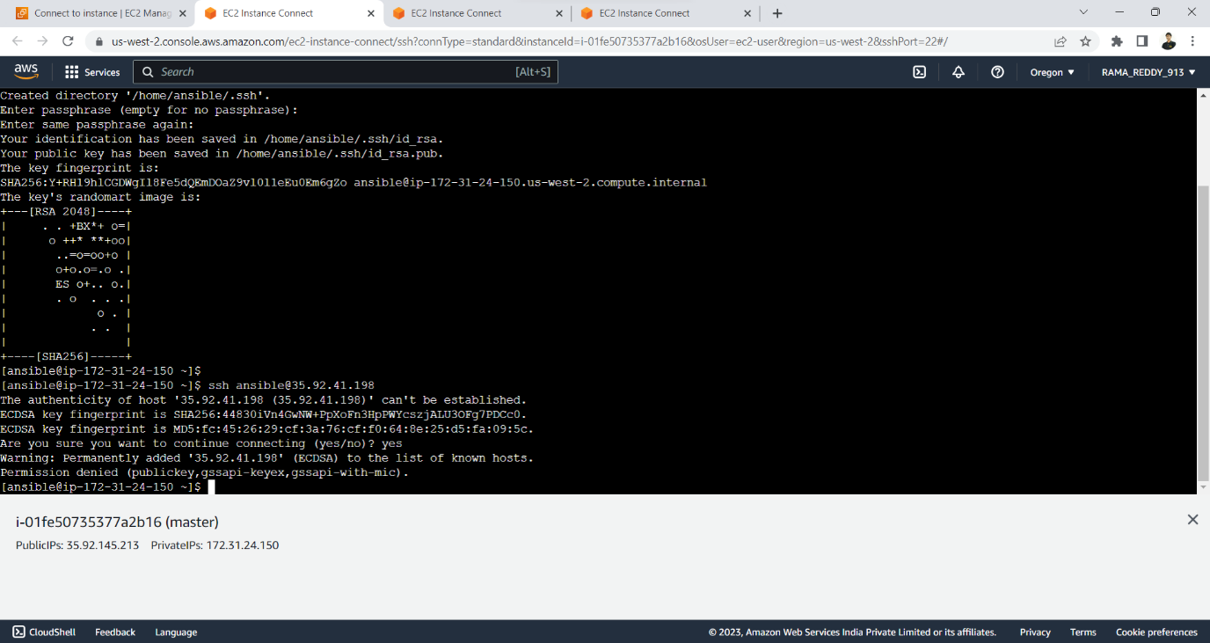restart sshd**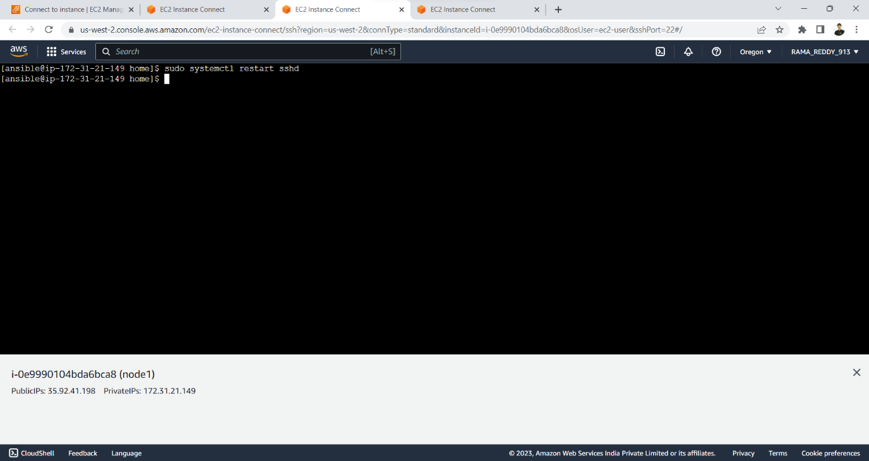

**copy public key generated to the nodes by using following command and now we can connet to the node securely by using ssh command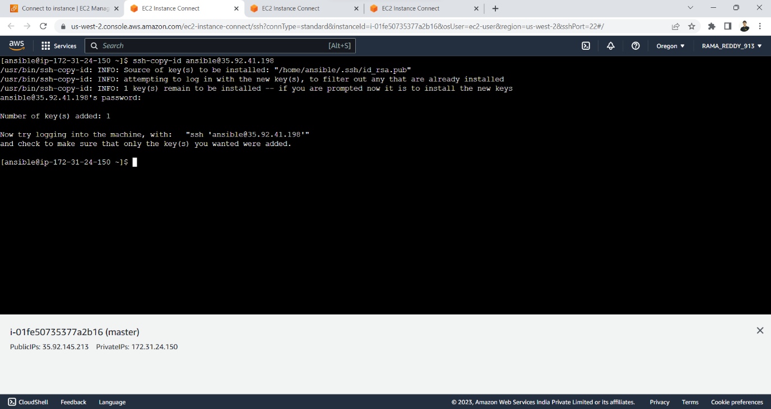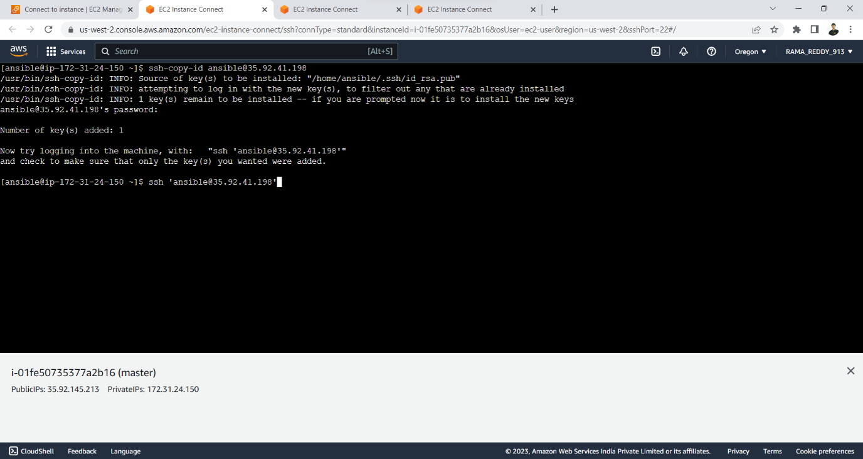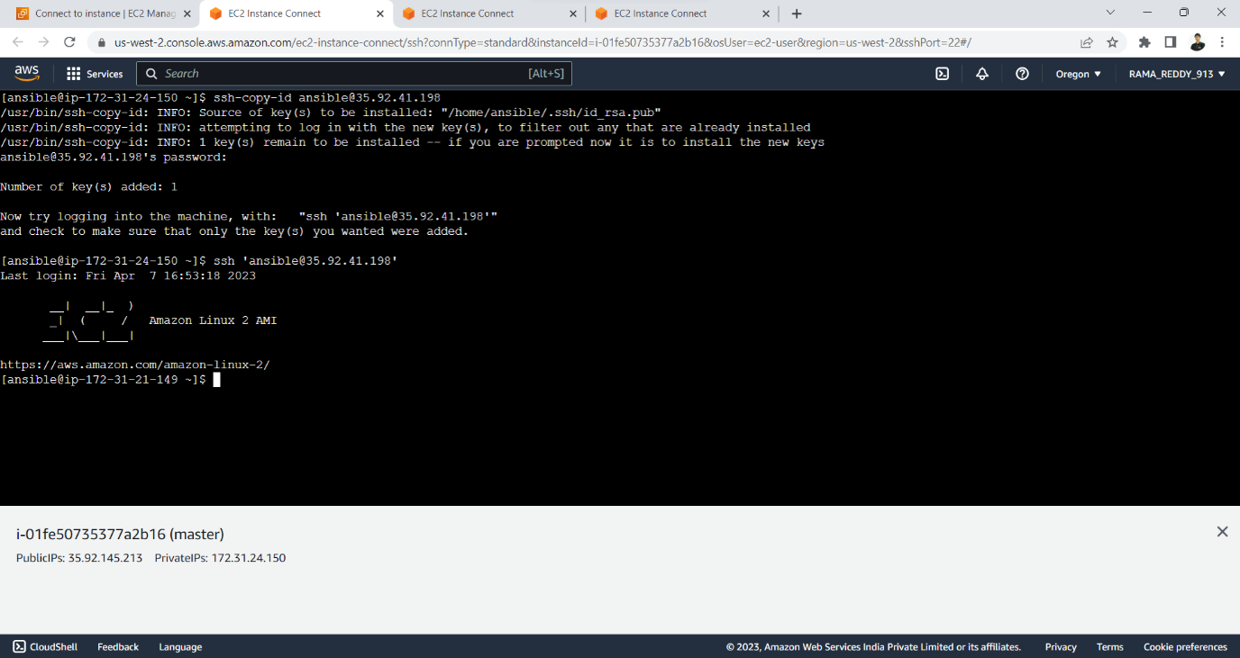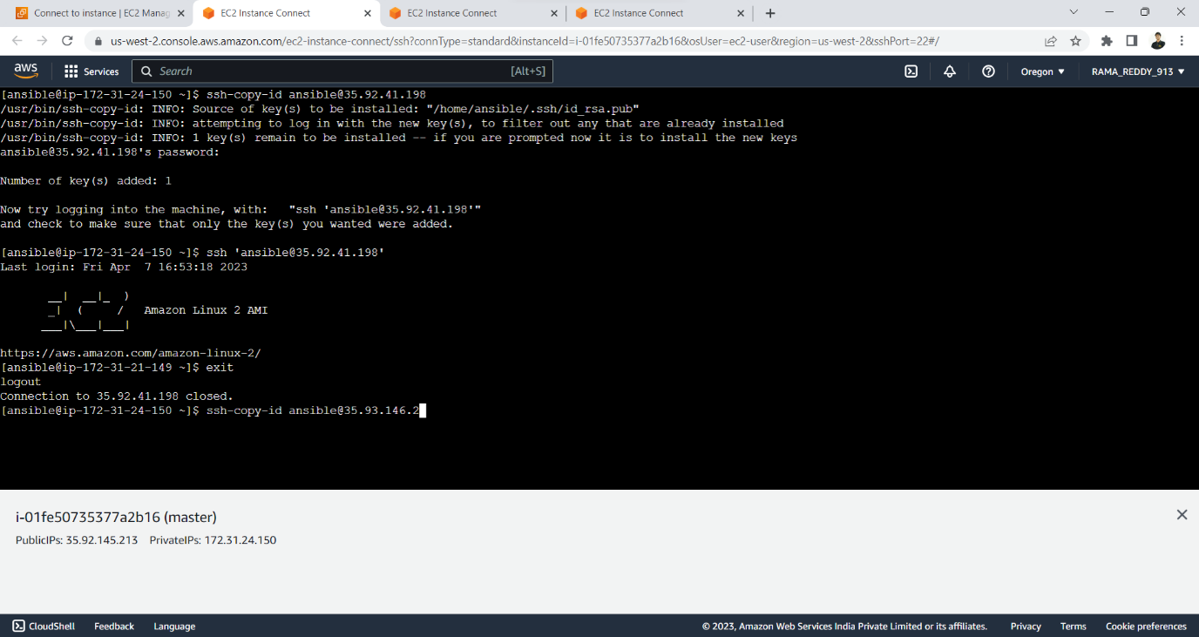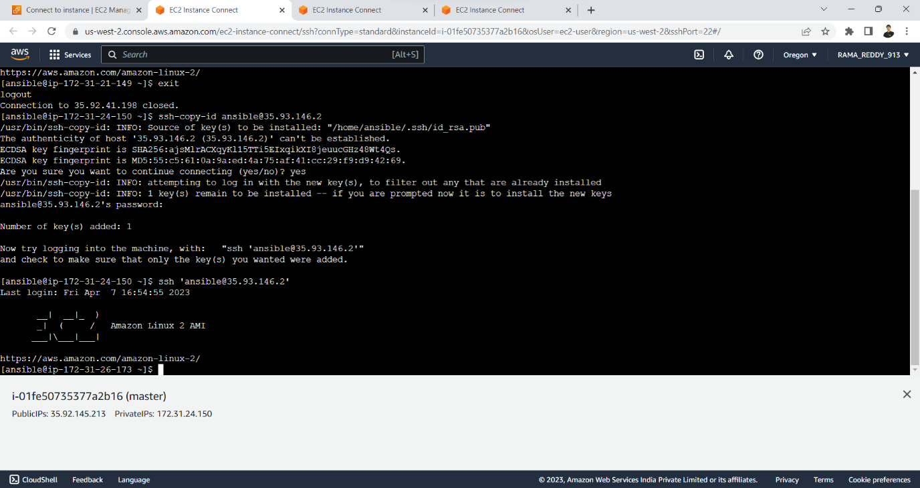the following yaml code will install git ,http on the nodes , starts the httpd server and clones the website application and copies it to /var/www/html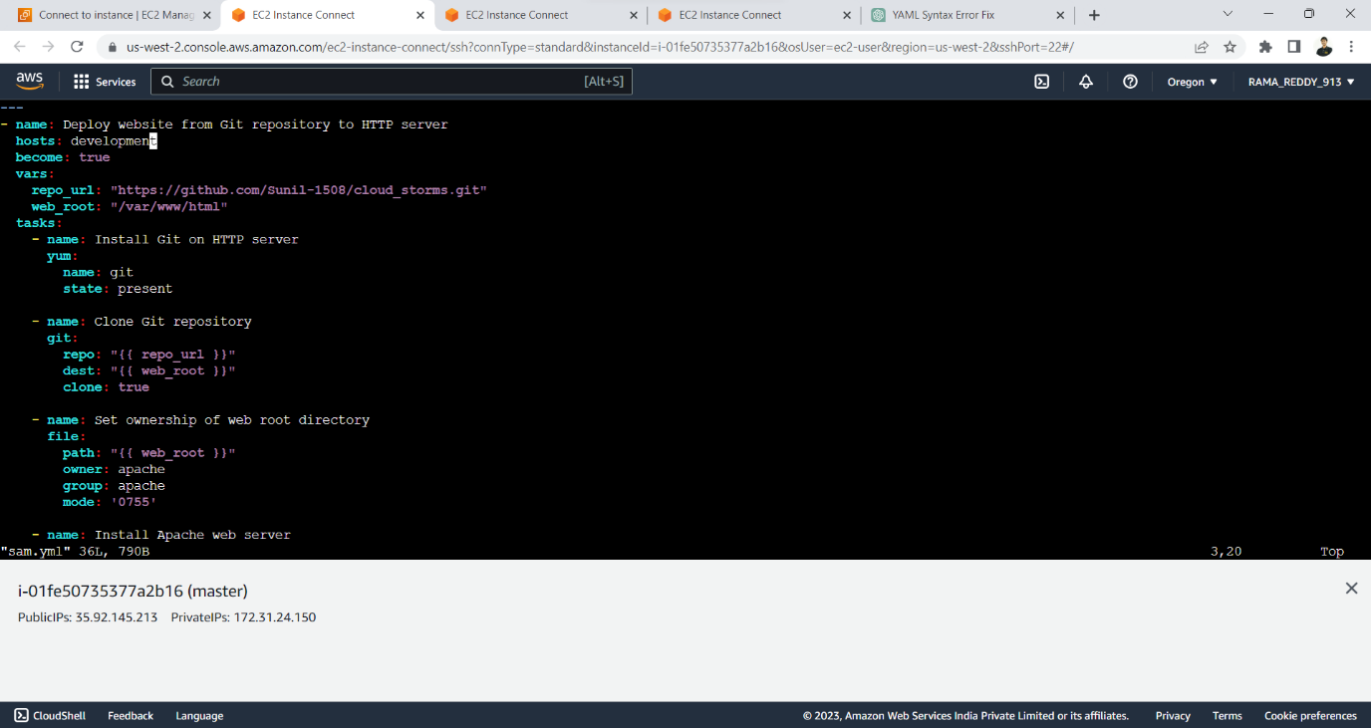run the ansible playbook by using ansible-playbook filename.yml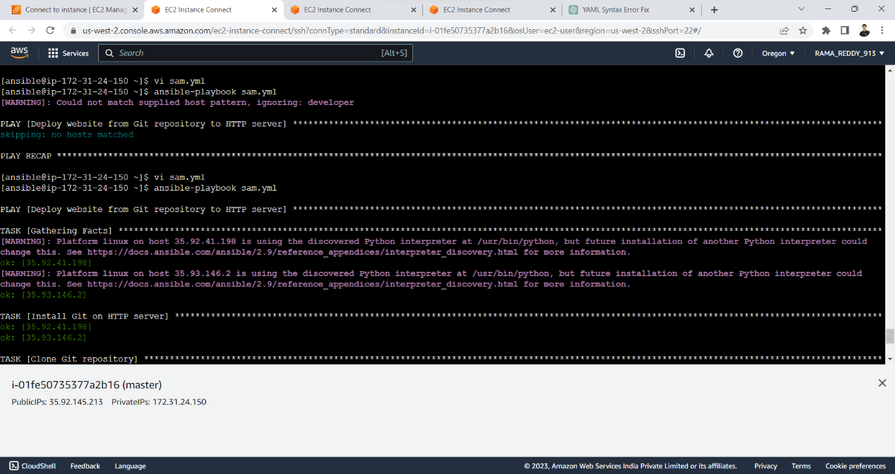now we can connect ot the website by using public ip address of the hosts**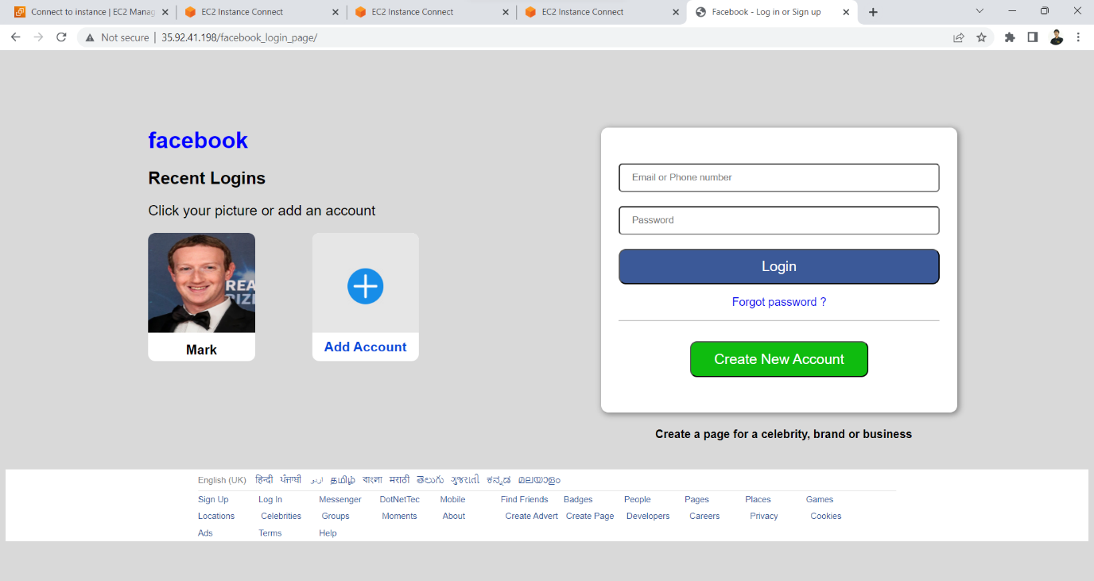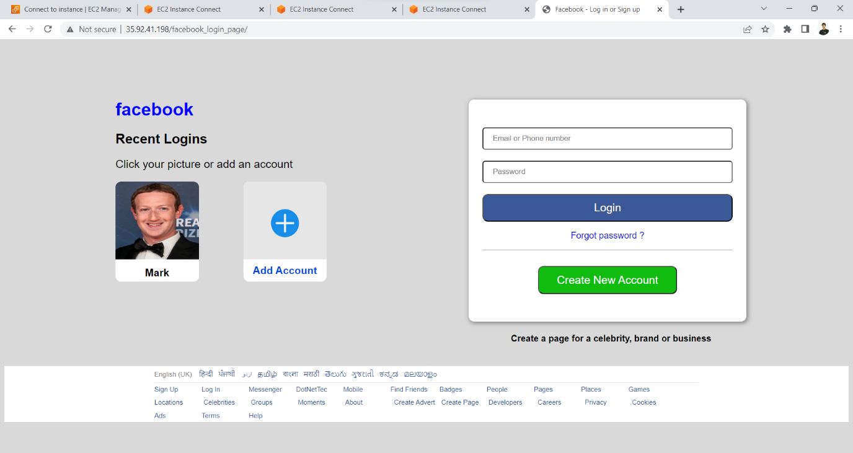

**REPOSITORY DETAILS:**

The frontend Facebook clone web application and YAML Playbooks we used in this project will be available in the following git hub repository

[**https://github.com/Sunil-1508/cloud_storms**](https://github.com/Sunil-1508/cloud_storms)

**OUTCOME:**

**Improved efficiency:** Ansible can automate repetitive tasks, such as software installation, configuration management, and infrastructure provisioning. This can save time and reduce the risk of errors that can occur with manual processes. As a result, IT teams can be more efficient and productive, focusing on more strategic work that adds value to the organization.

**Increased consistency:** Automation with Ansible ensures that IT operations are standardized and consistent, reducing the risk of errors and security vulnerabilities. Ansible allows you to define playbooks and roles that can be used across your organization, ensuring that tasks are executed in a consistent manner. This can help to improve the reliability and stability of your IT environment.

**Enhanced scalability:** Ansible is highly scalable and can automate tasks across large numbers of servers and devices. This makes it a valuable tool for organizations that need to manage complex IT environments. Ansible allows you to define groups of hosts and execute tasks across those groups, allowing you to easily scale your automation efforts as your environment grows.

**Reduced costs:** By automating routine tasks, Ansible can help organizations save time and reduce labour costs associated with manual processes. Ansible can also help organizations to avoid costly downtime by automating tasks such as system patching and updates.

**Improved collaboration:** Ansible provides a platform for collaboration between IT teams, allowing for the sharing of playbooks and roles that can be used across the organization. This can help to improve communication and coordination between teams, leading to a more efficient and effective IT operation.

**Enhanced security:** Ansible can help organizations maintain a strong security posture by automating tasks such as patch management, vulnerability scanning, and compliance auditing. Ansible can also help to enforce security policies across your environment by automating the configuration of firewalls, security groups, and other security-related tasks.

In summary, automating applications using Ansible can lead to significant improvements in efficiency, consistency, scalability, cost savings, collaboration, and security. These outcomes can help organizations to streamline their IT operations, improve productivity, and reduce the risk of downtime and security breaches.



**CONCLUSION:**

In conclusion, automating applications using Ansible can provide numerous benefits for organizations looking to improve their IT operations. Ansible is a powerful open-source automation tool that can be used to automate a wide range of tasks, from software installation and configuration management to infrastructure provisioning and deployment.

By automating routine tasks, organizations can improve efficiency, consistency, and scalability, while reducing the costs associated with manual processes. Ansible can also help enhance collaboration between IT teams, allowing for the sharing of playbooks and roles that can be used across the organization.

Additionally, Ansible can help organizations maintain a strong security posture by automating tasks such as patch management, vulnerability scanning, and compliance auditing. By leveraging Ansible's capabilities, organizations can achieve greater efficiency, cost savings, and security, while freeing up IT teams to focus on more strategic work.

The use cases for automating applications using Ansible are diverse and can be applied to a wide range of industries and organizations. From configuration management and continuous deployment to cloud automation and disaster recovery, Ansible can help organizations streamline their IT operations and achieve their business objectives.

Overall, the outcome of automating applications using Ansible can be significant improvements in IT operations, leading to a more streamlined and effective IT environment. By leveraging Ansible's capabilities, organizations can achieve greater efficiency, cost savings, and security, while freeing up IT teams to focus on more strategic work.

**REFERENCES:**

* Ansible Community Documentation(<https://docs.ansible.com/>)
* Git Tutorial(<https://git-scm.com/docs>)
* Ansible Tutorials (<https://youtu.be/zw8eUSGNLq4>)
* AWS Documentation (<https://docs.aws.amazon.com/>)

**CONTACT EMAIL’S:**

PRASAD REDDY [20a91a0547@aec.edu.in](mailto:20a91a0547@aec.edu.in)

NAGA BALAJI REDDY [20a91a0582@aec.edu.in](mailto:20a91a0582@aec.edu.in)

SUNIL [20a91a05b1@aec.edu.in](mailto:20a91a05b1@aec.edu.in)

RAMA REDDY [20a91a05c0@aec.edu.in](mailto:20a91a05c0@aec.edu.in)

